Response to reviewers

Thank you very much to the reviewer for the constructive and helpful criticism! We are very thankful for the care the reviewers have taken in their thorough evaluation and hope our changes to the paper are acceptable.

Responses the reviewer’s points are included in red.

Response to review 1

The paper has been revised well. The only minor suggestion would be to further improve the visibility of Figure 7 and 13. They are quite important and the information density is much higher compared e.g. to Figure 4 and 8 but have smaller size. Maybe you could split them to have them on two pages (base and yawed), respectively?
To increase this visibility, while maintaining the figures in one table for comparison, we have endeavored to reduce the amount of white space in the axis, between the axis, and on the borders to maximize the space used in plotting.

Response to review 2

The thoroughly revised paper “A simulation study demonstrating the importance of large-scale trailing vortices in wake steering” by Fleming et al. is well structured and almost addressed all comments of the previous review.
The main changes in the title, abstract and conclusions fit now to the delivering content of the paper. The major aspects are addressed for further publication in the Wind Energy Science journal. However, the following technical and minor comments should be considered.
Scientific comments:

1. P01. L18: The first two sentences read like wake deflection always (for all conditions, layouts, ...) leads to a large power gain. We did not address this in the first review but please rephrase the sentence and explicitly state that the net increase is referring to overall wind farm energy yield.
This has been re-written to: For certain arrangements of turbines, it can be shown that the power of the downstream turbine is increased by more than is lost by misaligning the upstream, yielding a net increase in power.
2. Previous Comment 38 on Fig. 3: We would prefer a different color scheme which conserves the content in grayscale as well as in color. Being consistent in the publications may be a desirable goal. However, from our point of view, it should be more important that the results are presented in the best possible way. Furthermore, we have to assume that if this issue is not addressed in this publication it is not going to be addressed in future work as well for the sake of consistency. The reviewer is convinced that a color scale can be found which meets the condition and can represent the desired velocity range.
We have changed the underlying color scale (using the matplotlib tool in python) from “coolwarm” to RgBu.
We first looked at changing from diverging color scales to continuous color scales, but this meant that the neutral 0 (no change value) is not white, and the resulting images were distracting because of color located everywhere (“plasma” is visualized here fore example):
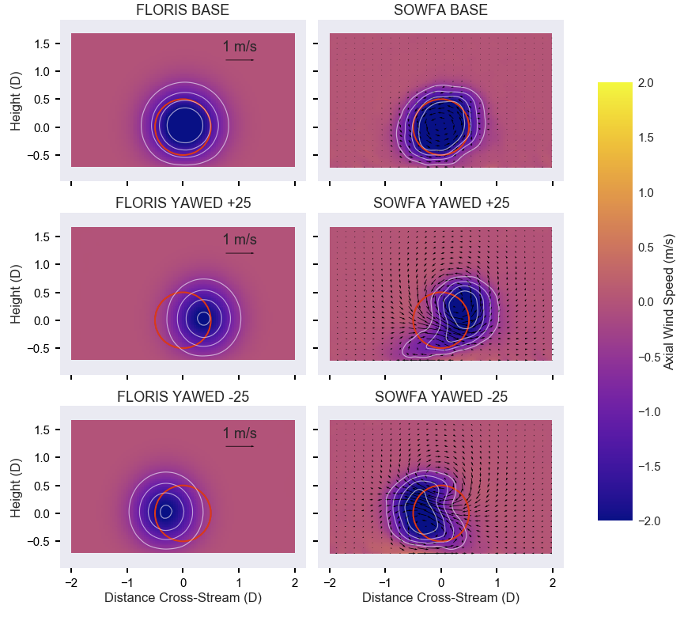
Focusing therefore on diverging schemes with white at 0, according to the documentation of matplotlib, this RgBu represents a best choice for a diverging color scheme (where 0 appears white) considering appearance in grayscale because, unlike coolwarm, it uses the full range of lightness:
Diverging
For the Diverging maps, we want to have monotonically L* increasing values up to a maximum, which should be close to L*=100 , followed by monotonically decreasing L* values. We are looking for approximately equal minimum L* values at opposite ends of the colormap. By these measures, BrBG and RdBu are good options. coolwarm is a good option, but it doesn’t span a wide range of L* values (see grayscale section below).
https://matplotlib.org/users/colormaps.html

This comparison shows the improved grayscale representation following the change:
Therefore, for figure 3 and similar, we switch the color scheme to RdBu
Editorial comments:

1. Sometimes the authors use “Fig.” and sometimes “Figure”. Please be consistent.
We have standardized on Fig.
2. P04. For Figure 1 and Figure 3 the authors state if the flow is shown from above or below and upstream or downstream. We assume it does not change for Figures 5,6, 7 and 13. Nevertheless, it should be stated once for all graphs or individually in all captions.
The following has been added: Note that for all figures, horizontal planes (such as Fig. 1) are viewed from above, while cross-stream planes (such as Fig. 3) are viewed from upstream.
3. P04. L08: “;” between multiple consecutive citations instead of “,.” (consistency throughout the paper)
This is generated by the latex/bibtex class and will ask the journal copy-editors assistance in formatting
4. P04. L07: year missing for reference: Katić
Fixed
5. P04. L28: typo “.” inside bracket: “… (see Fig 1.) Fig1 ...”
Fixed
6. P05. Fig.1: See previous #33. A coordinate system is still missing. It can be added as X and Y, i.e., streamwise and lateral horizontally direction, respectively. See also previous #26. Figure 1: Without a grid or ticks the use of the tick labels is limited.
We have re-labled the x and y axis as streamwise and spanwise and added a grid.
7. P05. L04: The referencing of FAST should be modified. Year is missing. In general the citation through the paper needs revision.
Fixed

8. P05. L14: “The simulation had 6% turbulence intensity with a shear exponent of 0.085.” 6% TI at hub height?
Yes, this is added to the text

9. P05. L16: “The simulations include National Renewable Energy Laboratory’s (NREL’s) 5-MW reference turbines from Jonkman et al. (2009), modeled as an actuator disk for computational efficiency.” => Please add “actuator disc with rotation” as you said you did in your response to previous comment #18. The following sentence suggests its use but it does not hurt to explicitly state it.
This is done
10. P10. L13: “25°yaw” - The template seems to account for only a very very small space between a degree sign and the next word/character. This looks unusual.
Fixed

11. P10. L14: "." missing at end of sentence after “Fig. 5”
Fixed

12. P13 Fig. 8 (see previous comment #54): add “at hub height” in the caption
These values are not completely at hub height, because they are averaged over a rotor being swept laterally, perhaps the phrasing “of a rotor centered at hub height?”
13. P14: It is better to merge section 5 with section 4, which represents the same two-turbine case study.
This was converted to a subsection of section 4
14. P14: Please correct the following typos, e.g., L13: ie, L16: ¼ D, L18: 2 D, L20: 14 D
Fixed “ie”, and converted the D notation to be in math formatting,
15. P14. L02: typo? “In the previous section, the concept of “secondary steering” is introduced, wherein, a steered wake, causes a deflection of the wake of a downstream turbine, this is not yawed. “ => “…, which is not yawed.”?
Fixed, thank you
16. P14. L09: Please rephrase this sentences "However, a possible alternative …" → the explanation is that the upstream turbine is producing a partial wake scenario vs the "secondary steering" could be related to the partial wake condition
This paragraph has been re-worked and merged with the following paragraph to clarify the meaning:
However, a possible alternative explanation is that the first deflected wake, is producing a partial wake scenario. FLORIS' wake combinations model, as described earlier, is based on sum of squares. Given that Trabucchi et al. (2017) shows that sum-of-squares superposition, as is used in FLORIS, has an error in prediction relative to newer methods, this could be the explanation for the discrepancy, i.e., partial wake overlap leads to an apparent secondary steering and improved wake combination models in FLORIS would resolve the discrepancy.
17. P14. L15: The sentence “The front turbine is moved down ...” is complex including too much information.
This has been divided into 3 sentences: However, in this case, the front turbine is moved down $1/4 D$. In this configuration the wake of the upstream turbine overlaps the downstream turbine in a similar location as the steered wake of the originally located turbine. However in this case the generated vortices are not produced.
18. P14. L21: Grammar revision is needed for sentence “you can that ...”.
Fixed

